 ACN 116231595

**2013 Annual Report**

**Australian Health Promotion Association (SA Branch)**

**President’s Report – Janette Young**

2013 was a year of significant changes whilst continuing to engage in core activities for AHPA (SA branch). In addition to the now regular activities of the mentoring program, ongoing committee meetings, working with PHAA in organising the State Population Health Conference, a core focus of energy this year has been on student related matters and engaging with like-minded other organisations. Changes included a largely new committee as we experienced a high turnover between 2012/13; trialling a student support team via the UniSA Bachelor of Health Sciences Field Placement course.

*UniSA Student support team* – Most of us learnt the skills needed to engage in committees in an ad hoc manner, however the future of voluntary organisations such as AHPA, and the health workforce regulatory framework are built on presumptions of these civic engagement skills (eg minute taking, regular meeting protocols, record keeping and management) continuing. So in 2013 the committee trialled using the student placement process in the Bachelor of Health Sciences to trial a hoped for win-win approach of teaching these skills to students whilst providing support to our volunteer committee members. It was a learning experience all round, but the overall feedback from the students and committee members (as you will see in some reports here) has been positive. We had two excellent students this year – Emma Barry and Emma Winen who each completed 120 hours of work for AHPA. They took minutes, developed agendas, organised filing and made lists of what exists, assisted in compiling the e-bulletin, person-ed an AHPA stand at the UniSA careers event, assisted with organising the 2012/13 AGM, organised a networking event, and I suspect I may have missed a couple of actions. An abstract regarding the trial was submitted to the State Population Health Conference and a poster developed (Appendix one: Poster). AHPA (SA) has submitted a Field Study request for 2014 and we are hoping to recruit a student(s) again. It was a valuable process all round.

*Career Development*  – a core focus of AHPA is on providing career development and support to members. The AHPA/PHAA *mentoring programme* which is run in conjunction with the PHAA, but with AHPA taking the lead (this leadership approach is reversed for the State Population Health Conference) continues to be highly successful. Jane Barnett worked alongside Kate Kameniar of the PHAA.

Our UniSA student team organised a very successful student careers evening which had about 50 attendees. The actual process of organising the event was great for the networking of our student team and they recruited a diverse team of presenters who had worked in both health and non-health settings. It is anticipated that should we successfully recruit more UniSA students that this event planning would become a core staple in a student placement. It gives students a focus and opportunity to learn and shine.

*Relationships* – Following the McCann Review, the SA Consortium of Health Organisations met with the Minister to discuss primary health needs and issues however the agenda of “cost-savings” so that the health budget can be brought in on budget was the dominant message. To strengthen our community connections we were accepted as members of SACOSS (South Australian Council of Social Services). SACOSS has been very active in responding to various health and health impacting issues in the state and it has been a privilege to work with Ross Womersley and Kate Kameniar. A team response approach organised by an entity such as SACOSS gives AHPA a voice at the table of many issues we hold dear.

Our close relationship with PHAA continues and the State Population Health Conference was again held. Many thanks to Susan Cameron who was our AHPA representative on the organising committee, and to Kristy Stengert who also provided input to this committee. The Centre for Health Promotion was the worthy recipient of the bi-annual Primary Healthcare Practitioners Award. Jenny Phillip-Harbutt received and responded to this presentation.

*Future relationships* - One of the tasks we undertook early in 2013 was to look at what PHAA policies could be identified as particularly pertinent to AHPA; meaning (for example) that should topics arise publicly it would be quick and easy for AHPA to offer their support to a shared policy stance. The outcome of this perusal was a shared sense from the committee that the PHAA policies were narrower than AHPAs broader health promotion conceptions. As per the Ottawa Charter and other documents we felt that AHPA needed to emphasize “health” and the active construction of such as versus illness or disease focussed frameworks. This lead us to discussions about how we might engage more with non-health identifying (but in fact health-promoting) entities such as planners, local governments, crime prevention, sport and recreation bodies. **Late in 2013 the Australian and New Zealand Association for Leisure Studies (ANZALS) approached AHPA (SA) to join with them in their bi-annual conference in 2016. As Branch President I feel strongly that this is a great starting opportunity for AHPA to be progressing in the non-health health promoting direction identified.** The proposal has been forwarded to AHPA National but it will be possible to undertake this at a Branch level should it not mesh with National AHPA at this time.

*Publicity* – AHPA was promoted at a number of events this year. Many thanks to Emma Winen and Emma Barry who person-ed the UniSA Careers fair AHPA stand; and to Adam Delaine who organised and then person-ed the similar event opportunity at Flinders University. Thanks to Stefania Velardo who supported Adam in this. The infographic (Appendix Two) developed at the National AHPA level has been a great tool for promoting and disseminating the health promotion message and it would be good if such a tool could be developed on a regular basis. This work came out of a workshop at the National conference focussed on the Federal election and how AHPA could be responding.

*Health Promotion Workforce advocacy* – This continued to be a focus of the SA branch in 2013. In March members of the state and national committees met with the CEO of Health Workforce Australia. We were informed that Health Promotion is on the list of work groups to be considered for inclusion under the banner of the health workforce regulatory system in Australia and as the entity representing the Health Promotion workforce, compared to a more general focus on population health, or on educating in this field**, AHPA would be seen as a key partner in any future discussions regarding this matter.** This links to and confirms the work being done at national level by AHPA regarding health promotion regulation pathways.

*Supporters*: AHPA is a membership based organisation with the only funds available to the Branch being from membership fees which are split between the National and Branch levels. There is now some contracted support via NFPAS (Not For Profit Accounting Specialists) who are relieving some of the administrative weight on our volunteer treasurers at both levels. However we rely on people donating their time and energy for AHPA to exist. It needs to be noted that we do receive a great deal of in-kind support that would cost a great deal if we needed to pay for the resources. In 2013 this support has come from COTA (Council of the Ageing) in the provision of venue space for minimal fees, and UniSA through the provision of rooms free of cost for regular committee meeting and one off events. As President I have received strong support from my direct managers (Professor Roger Eston and A/Professor Kerry Thoirs) at UniSA, for which I am very grateful and I would also like to thank the staff team I work with very closely - Drs Richard McGrath and Caroline Adams; and Ms Lisa Lawton.

*Thank-you committee!* This year, as always, the committee was comprised of a great bunch of talented individuals who dedicated precious personal time and energy to the collective health promotion work and workforce cause in SA. I would like to thank, Annabel Axford, Jane Barnett, Karen Garrett, Susan Cameron, Stefania Verlado, Liana Bellfemini, and Kristy Stengert who have been on the committee all year, plus many thanks to Adam Delaine and Alex Jackson who have joined us in the latter half of the year – Alex is taking over the Correspondence Secretary role having agreed to do this in response to being sponsored to the workshop run by Zockmelon on using Apps in Health Promotion. Luita Casey has been our ex-officio Aboriginal Health Promotion liaison and contact person. In particular I would like to recognise Jane Barnett (Treasurer) and Karen Garrett (Correspondence Secretary) who will both be stepping down from the committee in 2014. This will leave a huge gap as both are doyens of organisational skill, energy and ability. Jane in particular has been on the committee in various roles for many years. We wish them both well in their future endeavours.

We finished 2012 on a low note; however 2013 has brought new and positive relationships including a sense of enthusiasm and eagerness from working with a large number of students on the committee, and recruiting more through the year. Health Promotion has a bright future when I look at these people and the more we can support their enthusiasm and creativity the stronger our collective health promotion focussed future can be.



Dr Janette Young

President, AHPA (SA)

**Secretary Reports –Karen Garrett & Annabel Axford with students Emma Winen and Emma Barry**

**Correspondence Secretary –Karen Garrett**

The Correspondence Secretary is responsible for receiving, sourcing and distributing information from other organisations that may be relevant to the South Australian members such as upcoming events and employment opportunities. The Correspondence Secretary is also responsible for keeping members informed of events being facilitated by the SA Executive Committee along with relevant information from the Committee. The role also involves responding to enquiries from members and liaising with the National Secretariat as well as maintaining website content.

This year, I had the fantastic support of the UniSA student team in the development and collation of the monthly e-bulletin. I would like to thank them for their support during the year and I hope they found the experience valuable.

Toward the end of the year, Alex Jackson came on board to support me in this role as I look to transition the role over to him for next year. With some big changes personally and professionally, the time is right to hand this over to someone with greater capacity than I currently have to offer. This has led to the development of a number of templates and the start of a Tool Kit that can be used by people who take on this position in the future.

In 2014, Alex will be endeavouring to find more ways to connect with members through the use of the AHPA website and social media. We want to get better at providing you with information, job opportunities and events before they become irrelevant.

The e-bulletin continued to be distributed monthly during 2013, with a new look template used to allow members to find out more information in areas of particular interest.

Recommendations:

1. Further investigate the use of social media to communicate the members
2. Utilise the AHPA website as a way to connect with members and National Office
3. Enable members to complete a survey at the AGM where members can provide feedback about the e-bulletin

The Correspondence Secretary also provides a membership update at Executive Committee meetings.

All new and renewed financial members in the SA branch between December 2012 and November 2013 equated to 88. There has been a slight decrease in the number of full memberships and government organisation memberships while numbers in other areas have remained fairly constant.

|  |  |  |
| --- | --- | --- |
| **Membership Type** | **2012** | **2013** |
| Full Member (Australia) including Aboriginal or Torres Strait Islander | 51 | 41 |
| Student Member (Australia) | 40 | 39 |
| Community Organisation (Australia) | 2 | 3 |
| Government Organisation (Australia) | 9 | 5 |
| **Total** | 102 | 88 |

**Minutes Secretary – Annabel Axford with students Emma Winen and Emma Barry**

The Minutes Secretary is responsible for maintaining and recording the minutes of all branch meetings and the Annual General Meeting. This has included recording any Conflicts of Interest, the welcome (i.e those present), apologies, minutes of previous meeting (acceptance of), business arising, treasurers reports, portfolio group reports, new business, meeting close time and outlining an actions list. The minutes were set out in the minutes to include information on how the corresponding portfolios address the aims of the committee aligned to the National Key Focus Areas: Leadership and Professional Excellence; Advocacy; Communication and Marketing; and Governance. After the meeting the Minutes Secretary circulates the draft minutes for comment then sends the final version to all committee members prior to the following meeting. Once moved and seconded, minutes can be uploaded onto the SA Branch webpage (for members only).

This year enabled two students Emma Winen and Emma Barry take a lead minutes secretary role in committee meeting processes and active participation. The AHPA SA Branch placement was to support these students skills and experience in developing APHA Health Promotion Partnership Building, Communication and Report Writing; Core Competencies for Practitioners. This experience was showcased at State Population Health Conference in November 2013 in a poster format called “Learning civic skills as part of a University experience program” (Appendix one: Poster). APHA SA Branch would like to congratulate both Emmas on their involvement and participation in this lead and key role with the AHPA SA Branch.

**Treasurer’s Report – Jane Barnett**

2013 has been a financially successful year for AHPA (SA Branch) with an end of year balance at a position that reflects the reduced income as we are no longer funded by SA Health to provide capacity building projects in SA. The main source of income is from capitation from National AHPA – this year we received $2135.95. The financial system that was set up in 2006 has been simplified such that ATO reporting is now largely the responsibility of NFP Accounting Specialists. State Treasurers can still track expenses and make reports but do not need to send information for BAS statements or audits.

Please refer to the financial report below for information on income and expenditure.

Opening balance 1st January 2013 $7888.31

Closing balance as at 31st December 2013 $6402.10

|  |  |
| --- | --- |
| **Income for the year ended 31st December 2013** | |
| **Date** | **Total** |
| January | $365.00 |
| February | $250.00 |
| March | $2,207.11 |
| April | nil |
| May | nil |
| June | $7.34 |
| July | nil |
| August | nil |
| September | $6.80 |
| October | nil |
| November | $137.50 |
| December | $6.09 |
|  | **$2979.84** |
|  | |
| **Expenses for the year ended 31st December 2013** | |
| **Date** | **Total** |
| January | $1196.24 |
| February | $596.93 |
| March | $22.00 |
| April | $800.00 |
| May | nil |
| June | nil |
| July | $338.03 |
| August | $422.40 |
| September | $231.72 |
| October | $188.33 |
| November | $652.44 |
| December | $17.96 |
|  | **$4466.05** |

**ACTIVITY REPORTS**

**Mentoring – Jane Barnett**

The mentoring program is offered in partnership with the PHAA (SA Branch). The program aims to provide mentees with the opportunity to receive guidance regarding career opportunities, be provided with information and advice, and to draw on the skills and knowledge of experienced health promotion and public health professionals. The program generally focuses on students, early career professionals, and people seeking career transition or professional development regardless of the stage they are at in their career.

This is fourth year the SA Branches of AHPA and PHAA have partnered with the AHPA Northern Territory Branch and this year PHAA NT came on board with three mentees and two mentors participating.

It was another successful year with 25 mentees involved compared to 28 mentees in 2012. Maintaining a high number of participants in the program can be attributed to an increased awareness of the program over the years, positive partnership building between SA and NT and hopefully a result of the positive experiences of past participants. It commenced in early June with an introductory session held for participants and concluded with a celebration event in late November. This allowed participants to share their experiences and it provided another networking opportunity. Both events were well attended and positive feedback was received by participants.

This year, mentees expressed a broad range of interest in public health and health promotion areas. Mentors represented a variety of areas across government and non-government and academic institutions. These included: research, policy, evaluation, primary prevention, oral health, public health, sexual health, medicine and Aboriginal health. In the applications mentees identify their mentoring needs (they can choose more than one category): nine were current students, eleven were in their early career, ten were seeking professional development and five nominated support for career transition.

Feedback indicated that mentees’ objectives were either partially or fully met. Unusually, this year we had a mentee from last year offer to be a mentor this year and then also apply to be a mentee again. This young public health doctor was inspirational in both roles and has benefited greatly in developing her career plans. To quote feedback from one mentee: “it is a great program to get involved with and I will recommend it to my peers, as it can give you a greater insight into what your possible future career could entail”. Valuable feedback from a mentor: “it was great to have the opportunity to reflect on how far I had come since my early career, and pass on some of those learnings, and to hear about another’s work and talk through issues and experiences”.

AHPA is extremely grateful to the mentors as the success of the program is dependent on their commitment. I would like to acknowledge the support of Kate Kameniar (PHAA SA Branch) and Cathy Malla (AHPA NT Branch) in facilitating this year’s program.

**Professional Development/ Networking – Annabel Axford**

Major Events for 2013:

* **Annual General Meeting & Breakfast – 22th February 2013.** Held at COTA, Hutt Street Adelaide. The guest speakers from UniSA (Richard McGrath) and SA Health (Carmel Williams) Health in All Policies team presented to members and guests.
* **Planning Day – 9thMarch 2013. He**ld at Royal Adelaide Hospital Wellness Centre, North Terrace, Adelaide. The planningday allowed the SA Branch Management Committee and other AHPA members to reflect on current priorities and issues by seeking SA membership input and devise strategies for the year ahead. For 2013 it was decided to continue working towards the professionalisation of health promotion and engaged Heath Workforce Australia.
  + **Mentoring Networking Session - 5thJune 2013.** Held at UniSA City East, Bonython Building (BJ) Level 2. Room 2-20. This was an introductory sessionfor participants, this event was well attended and positive feedback was received by participants.
  + **Mentoring Mid Program Networking Session -14th August 2013.** Mid program networking session prior to the PHAA Careers and Networking Evening at the Belgian Beer Café.
  + **Student Networking Session - 8th August 2013.** UniSA student team organised a very successful student careers evening held at UniSA, City East Campus, Bonython Jubilee Building, Room BJ2-20. The guest speakers were from speakers from multiple areas of health workforce such as Council (OPAL), Town Planner and Medicare Local. The session was well attended with about 50 attendees from three universities attending the session.
  + **State Population Health Conference - 26th November 2013. H**eld at Education Development Centre, Milner Street, Hindmarsh was an excellent conference and was attended by a number of members with two students on placement with APHA SA Branch Emma Winen and Emma Barry presentation their poster “Learning civic skills as part of a University experience program” (Appendix one: Poster).
  + **Mentoring Networking Session - 20th November 2013.** Concluded with a celebration event at the Richmond Hotel, Rundle Mall Adelaide to allow participants to share their experiences and it provided another networking opportunity with event was well attended and positive feedback was received by participants.

**Students on the 2013 Committee (Kristy Stengert and Alex Jackson)**

As a student member of the AHPA committee, there are a lot of opportunities for learning and gaining new experiences. We are given a firsthand look inside how a committee functions, all the work involved and the many roles that need to be filled.

There have been opportunities to be involved in events such as the annual AGM and State Population Health Conference, which were not only a great way to learn about how these events work, but also a great way to network with other members of the health promotion industry.

By creating a Student Sub-Committee, we were able to organise events that would be targeted primarily at students, such as the Student Networking Night, which provided opportunities to meet potential employers and attain advice on gaining employment within the industry. It is opportunities like this that make being a student member at AHPA, a well worth asset to have.

There are positions available on the AHPA committee that allow for great student experience. This can involve anything from a general committee member to more executive roles which explore many areas of the health promotion field. It is an excellent opportunity to liaise with other members who have a fantastic health promotion background.

Being a student member of AHPA is a great way to gain the upper hand in the health promotion industry and is highly recommended to anyone interested in this pathway.

**2013 AHPA Student Awards**

In 2003 the Australian Health Promotion Association (SA Branch) established an award for one student from each of the universities in South Australia. The criteria established for these prizes is a combination of academic achievement and demonstration of a commitment to Health Promotion.

Students receive recognition, a certificate, book voucher, and are eligible to be the student representative on Australian Health Promotion Association, (SA Branch) Committee

The very worthy 2014 AHPA student prize winners are:

University of Adelaide – Aimee Brownbill

University of South Australia – Chanthy Korb

Flinders University – Sarah Morphett

**Communication and Marketing – Karen Garrett**

The Communication Portfolio is focused on developing and maintaining communication strategies to provide members with relevant information.

The e-Bulletin continued to be the main method of communication in 2013 and ten issues were sent to members. Sent out monthly, the e-Bulletin was used to promote the events being held by AHPA SA, along with other information, professional development opportunities and events relating to health promotion and public health. Members are encouraged to submit items for inclusion in the e-Bulletin. Several members took this opportunity throughout the year, enabling them to circulate information, event details and employment vacancies to a wider network.

In addition, the use of new email, other IT option and social media as a way of communicating with existing members and attracting new members to the AHPA SA Branch is currently being investigated.

## AHPA Strategic Plan 2009– 2012 (currently under review)

### Strategic Priorities 2009-2012

AHPA’s overall goal is to encourage and support best practice in health promotion so that everyone can enjoy good health. AHPA will work towards this through the following areas:

1.  Leadership

2.  Strategic partnerships and alliances

3.  Professional excellence

4.  Advocacy

5.  Communication, and

6.  Good governance.

### Vision

The Australian Health Promotion Association is acknowledged as a national voice for health promotion in Australia and a major contributor to the health of all Australians.

### Mission

To advocate for health promotion, the health promotion workforce, and best health promotion practice.

### Values

The Australian Health Promotion Association's values are those enshrined in the Ottawa Charter for Health Promotion. They include equity, social justice, and shared responsibility for health.  The Association's values are expressed in professional excellence, and ethical practice.

### Strategic Plan 2009 - 2012

The Australian Health Promotion Association (AHPA) encourages and supports best practice in health promotion in Australia, in order that everyone may enjoy good health. The Association endorses the World Health Organization’s definition of health promotion: the process of enabling people to increase control over the determinants of health and thereby improve their health. Full document [www.healthpromotion.org.au](http://www.healthpromotion.org.au)

Appendix One: Poster

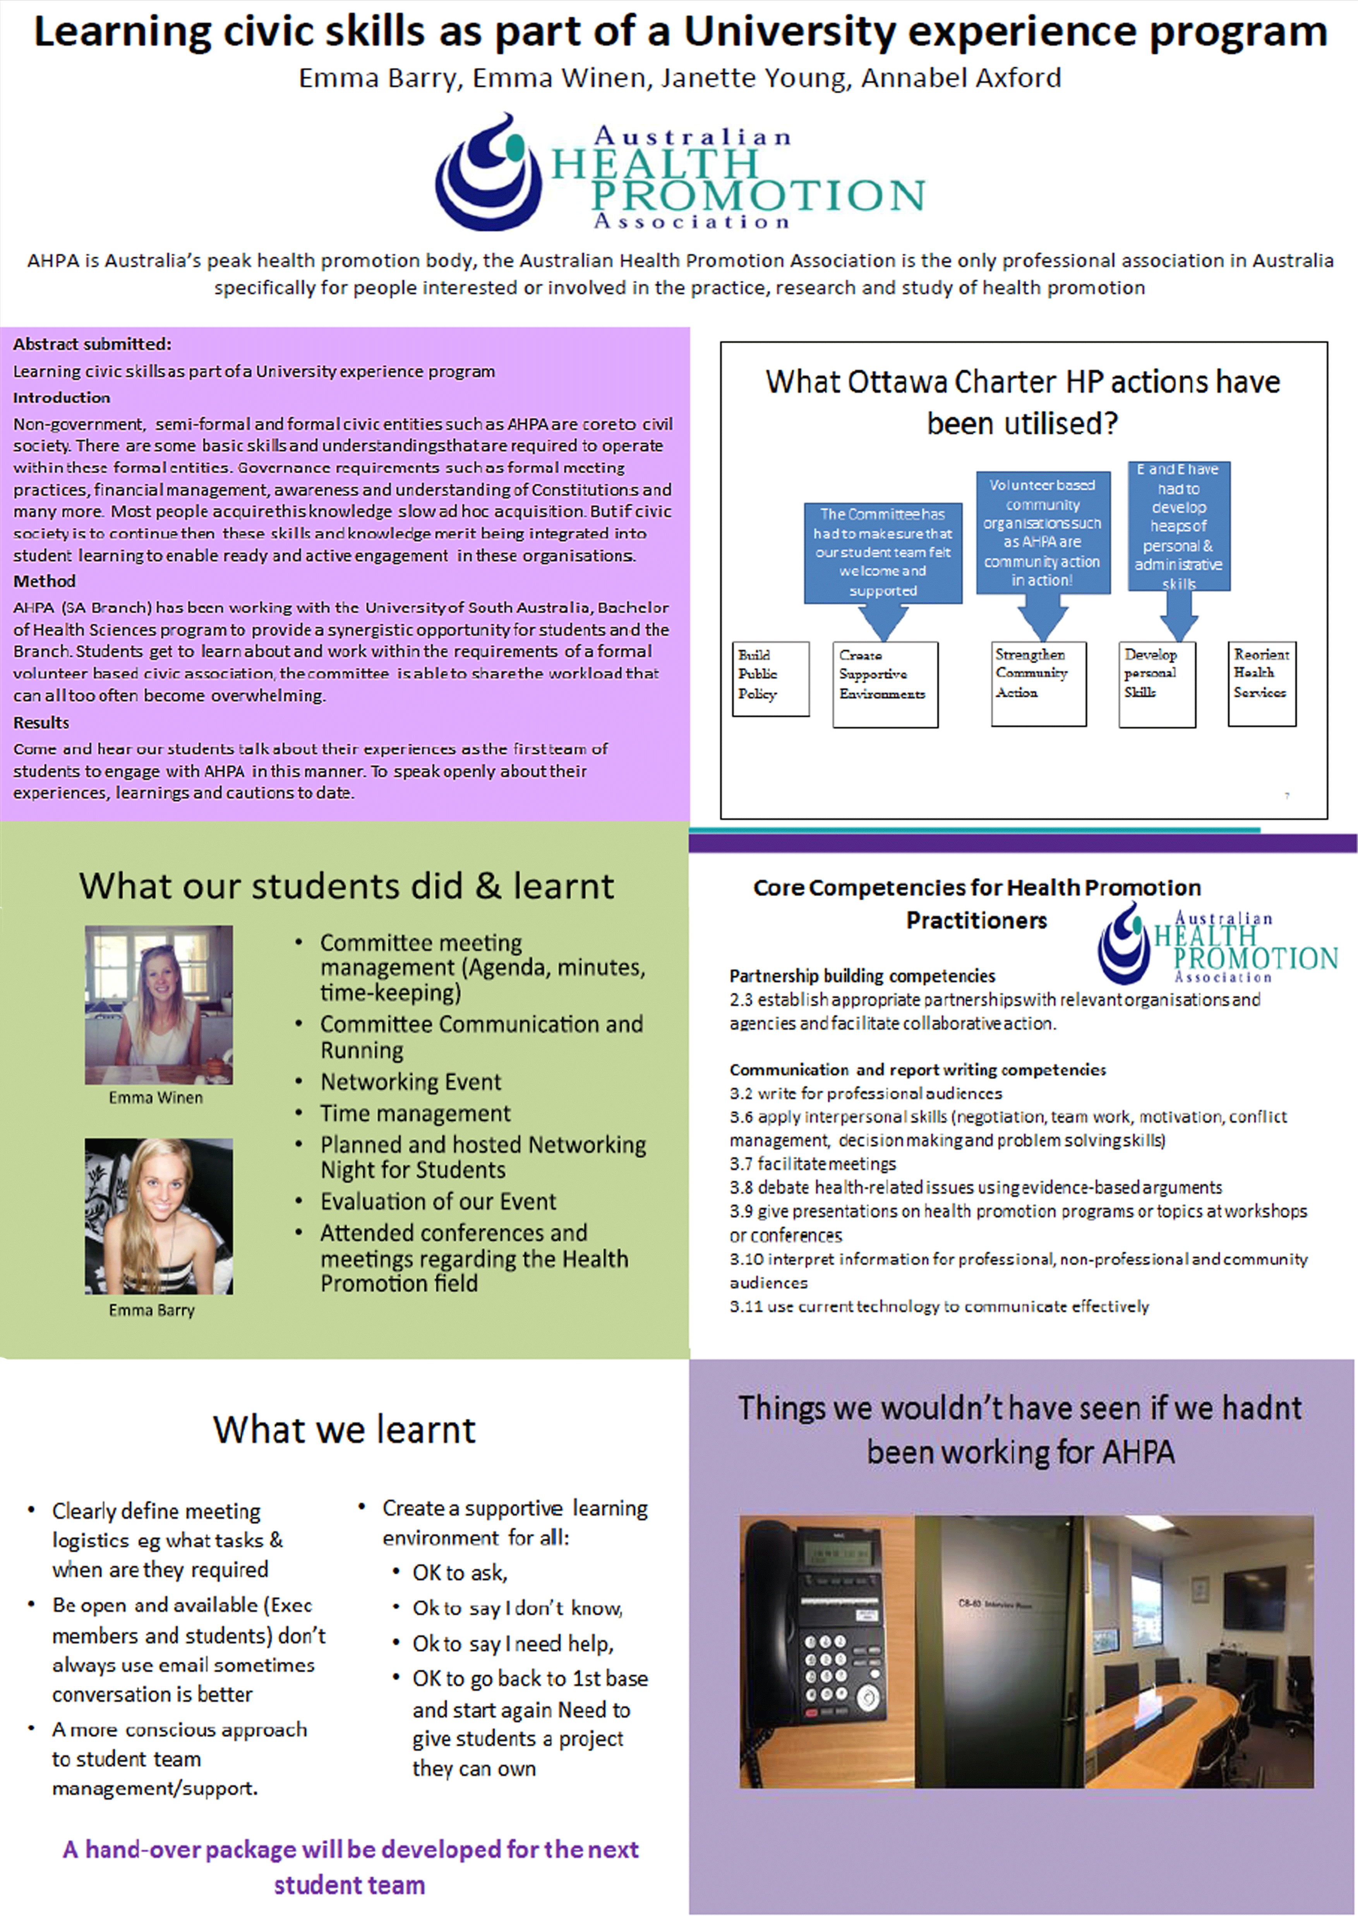

Appendix Two: Infographic

